CSA-FIN-RD-0888

Canadian Space Agency
Office of the Chief Financial Officer (OCFO)

Cost Analysis Data Requirements (CADRe)

PART A

Mission : CASCE

Key Decision Point : CDR

EPMO Gate : Gate R3

Draft 1 (Initial Release upon approval)

August 19, 2026

This Page Intentionally Left Blank
Revision History
Rev. | Description | Prepared by | Date
Draft 1.0 | Initial draft | STUDENT | 22 September 2026

Table of Contents
This Page Intentionally Left Blank
1 Introduction 7
1.1 Purpose of this document 7
2 General Descriptive Information 7
2.1 Mission Overview 7
2.2 Context 8
2.3 Strategic Objectives 9
2.4 Selected Mission Requirements 9
2.5 High-Level Mission Architecture 11
3 Space Segment Description 12
3.1 Spacecraft Bus 12
3.2 CASCE Payload 12
4 Launch Segment description 14
5 Ground Segment and Mission Operations 14
6 System Engineering and project management approach 15
6.1 TRL Levels and Heritage 15
6.2 Phasing Logic and Naming conventions 15
6.3 CSA PRoject Milestones 16
6.4 Safety and Mission Assurance 16
6.5 Qualification and Acceptance Strategy, MODEL Philosophy 16
6.6 Risk Assessment 17
6.7 Organizational Breakdown Structure 17
Appendices 19
A Acronym List 20

List of Figures
FIGURE PAGE
Figure 1 - CASCE Mission Concept 8
Figure 2– optical path from telescope to focal plane array 13

List of TABLES
Table 2 - Strategic Alignment 9
Table 3 – Selected System Requirements 10

Introduction

Purpose of this document
CADRE Part A provides a concise, standardized synopsis of the mission or project to support costing and analysis activities. Its primary purpose is to consolidate information from multiple technical and programmatic source documents into a single, normalized reference.
Specifically, CADRE Part A:
- Summarizes key mission characteristics in a consistent and structured format
- Aggregates information drawn from multiple authoritative technical documents
- Reduces the need for analysts to repeatedly consult disparate source materials
- Ensures a common baseline description is used across analyses
- Improves efficiency, traceability, and consistency in downstream costing work
In practical terms, CADRE Part A functions as a time-saving reference document that enables analysts to quickly understand the mission context without re-interpreting or reconciling multiple source documents.

General Descriptive Information

Mission Overview

The **Canadian Asteroid Surface and Composition Explorer (CASCE)** is a proposed Canadian scientific instrument that would fly as part of a European deep-space planetary mission. The mission’s primary objective is to identify and characterize small asteroids that have not yet been studied in detail, with particular emphasis on understanding their composition, surface properties, and thermal behaviour.
CASCE would operate as a remote-sensing instrument, observing selected asteroids during close encounters and collecting measurements across multiple wavelengths. These observations would allow scientists to distinguish between different surface materials and investigate how asteroids have evolved since the early Solar System. The instrument would also contribute measurements of asteroid size, temperature, surface variability, and potential indicators of hydrated or carbon-rich material.
The Canadian contribution would consist of the CASCE instrument and its associated data-processing system, while the spacecraft, launch vehicle, and primary mission infrastructure would be provided through a European-led partnership. This arrangement would give Canada a focused scientific role within a larger international planetary mission while allowing the instrument team to develop specialized capabilities in asteroid observation and analysis.
A key feature of CASCE would be its ability to operate autonomously during short observation opportunities. Because spacecraft resources and asteroid encounters are constrained, the instrument would prioritize observations based on target visibility, expected scientific value, spacecraft pointing constraints, and available communications and power. The resulting data would be transmitted to Earth for calibration, processing, and scientific analysis.
The mission would ultimately create a comparative dataset of asteroid properties, helping researchers investigate the diversity of small bodies in the Solar System and improve understanding of the materials from which planets and other larger bodies formed. The fictional mission therefore combines Canadian instrumentation expertise with European spacecraft capabilities to conduct a focused investigation of previously poorly characterized asteroids.
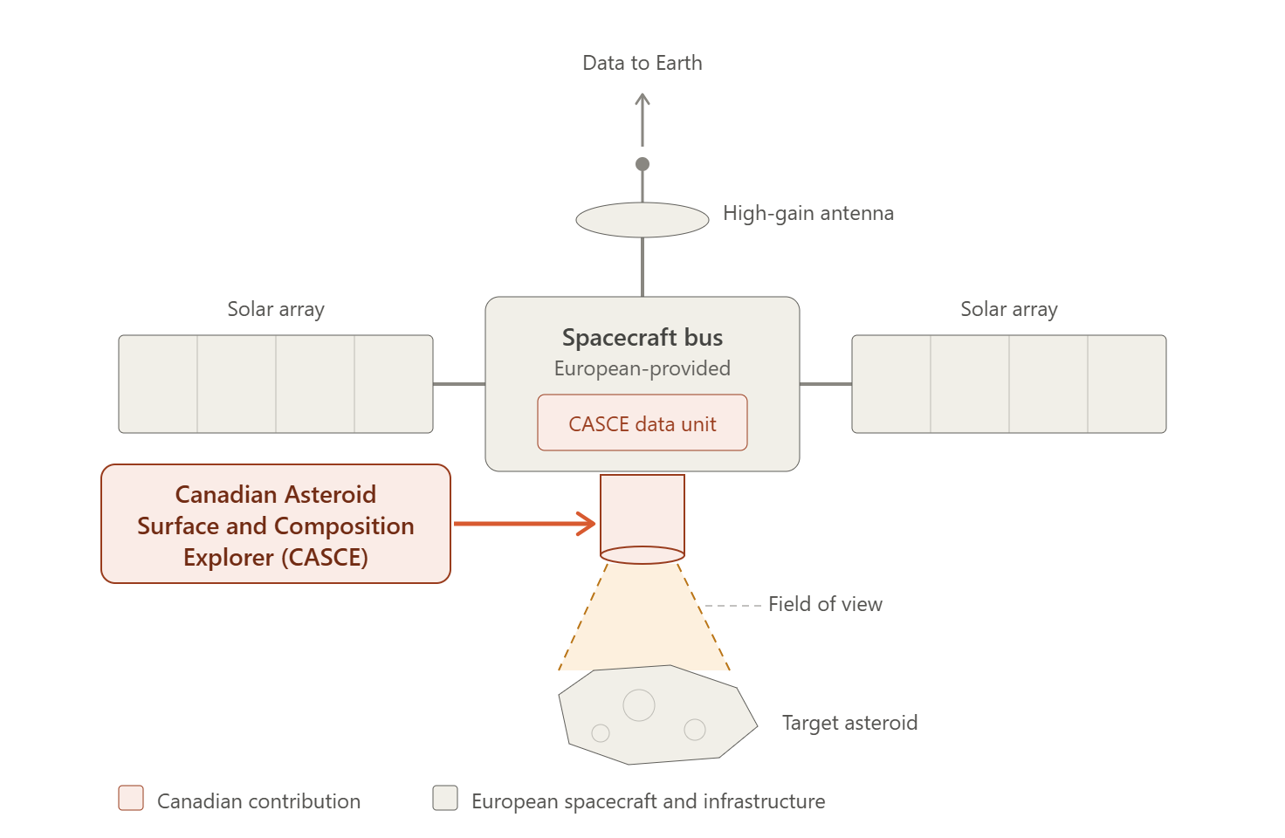
Figure 1 - CASCE Mission Concept

Context
The conceptual mission draws organizational and programmatic inspiration from STONECHASER, Canada's deep-space instrument contribution developed for a prior international planetary mission. STONECHASER demonstrates relevant Canadian heritage in international instrument contribution, deep-space remote sensing, and long-duration government-industry mission delivery.
STONECHASER demonstrates relevant Canadian heritage in:
- international instrument contribution to a foreign-led deep-space mission;
- small-body and planetary remote sensing;
- government-industry cooperation between CSA and Canadian industry;
- small, focused instrument team management within a larger mission structure;
- science data delivery and archiving agreements with an international partner; and
- long-duration deep-space instrument operations.
STONECHASER's instrument design, host mission, and target body were substantially different from the proposed CASCE mission. It is therefore used only as a programmatic heritage reference; the CASCE cost and schedule baseline is driven by the CASCE architecture, current PM schedule, procurement model, and finalized CADRe Part C / Part D assumptions.
Reference industry responses and market observations are retained only as concept-development evidence; they do not establish CASCE procurement partners. The finalized procurement baseline is defined in CADRe Part D and identifies CSA, ESA, Northstar Space Systems, Borealis Optical Systems, Nordholt Imaging Technologies, Chinook Avionics, and Canadian university/research institutions as the relevant organizations.
The CASCE CADRe baseline in this document is the controlling Part A reference for the current cost estimate. Any change to the mission architecture, schedule, procurement model, or organizational baseline shall be reconciled with the finalized CADRe Part C and Part D documents.

Strategic Objectives
Consistent with the Government of Canada's Space Policy Framework, the CASCE mission supports the following 3 main strategic goals:
Table 2 - Strategic Alignment
 | Strategic Goals | Space Strategy
1 | INSPIRE | Places a Canadian instrument on a deep-space mission, giving Canadians a tangible connection to the exploration of asteroids and the early Solar System.
2 | ENABLE | Builds specialized instrumentation and autonomous data-processing expertise in Canada that can be applied to future missions and commercial opportunities.
3 | DISCOVER | Expands knowledge of small-body diversity and of the materials from which planets formed, including indicators of hydrated or carbon-rich material.

Additionally, CASCE contributes to Space Diplomacy through international partnerships.

Selected Mission Requirements
The following table presents a summary of selected mission requirements. The complete and authoritative set of requirements is contained in the Mission Requirements Document ( link MRD).
- Asteroid Composition: Identify the surface materials of small, previously uncharacterized asteroids, including hydrated and carbon-rich material.
- Surface & Thermal Properties: Characterize asteroid surface variability, temperature, and thermal behaviour.
- Physical Characterization: Determine the size and basic physical properties of the target asteroids.
- Small-Body Diversity: Build a comparative dataset that reveals the range of composition and surface properties across the asteroids observed.
- Solar System Origins: Understand how asteroids have evolved since the early Solar System and the materials from which planets and other larger bodies formed.
Table 3 – Selected System Requirements
Area | Key requirement
Target coverage | Observe each selected asteroid target during its close encounter window, achieving at least 90% surface coverage of the illuminated hemisphere where geometry permits.
Encounter revisit | Acquire a minimum of two independent observation passes per target within a single encounter, separated by sufficient rotational phase to sample at least 50% of the surface at different local times.
Mission target count | Characterize a minimum of [X] asteroids over the mission lifetime, with a goal of [Y].
Field of view and pointing | Provide an effective field of view sufficient to keep the full target disk within frame at closest approach; valid observations must remain within [Z]° of the commanded boresight pointing accuracy.
Spectral capability | Acquire co-registered imagery and spectra spanning visible, near-infrared, and thermal infrared bands, sufficient to distinguish silicate, hydrated, and carbon-rich surface material.
Spatial resolution | Maximum ground sampling of 5 m/pixel at the design closest-approach distance, in the visible/near-infrared band.
Radiometric performance | Absolute radiometric accuracy of ±5% in the thermal infrared band and ±10% in the visible/near-infrared bands.
Geolocation | Level-1b products must be co-registered across bands to within 0.5 ground-instantaneous-field-of-view, at 95% confidence.
Canadian data latency | Deliver Level-1b data products to the Science Operations Centre within [X] hours of downlink from the spacecraft.
International latency | Deliver international observations within 90 minutes; 20 minutes is the goal.
Mission life and availability | Provide an operational lifetime aligned with the host mission's cruise and encounter phases, with at least 90% instrument availability during each planned encounter.
Operations | Support onboard storage for at least two orbits, special tasking within 12 hours, and integration with CSA’s Multi-Mission Operations Centre and Canadian ground stations.

High-Level Mission Architecture
Owned and operated by CSA, the mission consists of
- A Government Segment: consisting of government resources for oversight and their associated management costs such as T&L
- A Space Segment: consisting of four spacecrafts with a platform/bus and a infrared instrument.
- A Launch Segment: consisting of the launcher and launch service provider. Provided by ESA.
- A Ground Segment: consisting of facilities and equipment to plan and command acquisitions, as well as, to receive, archive and process data acquired by the satellite. Provided by ESA.

- An Ops Segment: consisting of personnel to handle real-time operations and some O&M costs. Provided by ESA.

- A Science Segment: consisting of scientific leadership, research teams, and supporting infrastructure responsible for mission science planning, calibration and validation, data analysis, scientific data products, user support, and the maximization of scientific return from the mission.

Space Segment Description
The space segment consists of a constellation of 4 spacecrafts, each with a bus and a payload. The 4th spacecraft is an on-orbit spare.

Spacecraft Bus
CASCE would be accommodated on a mid-size interplanetary spacecraft bus supplied by the European mission partner. The bus is a modular, flight-proven platform with prior heritage in deep-space orbiter and flyby missions, built around a composite honeycomb structure sized to support multiple science instruments through extended cruise phases and discrete close-approach encounters.
Power comes from deployable solar arrays feeding a rechargeable battery, sized for the mission's operating distance from the Sun. Propulsion combines a main chemical engine for trajectory maneuvers with smaller thrusters for the fine pointing needed during asteroid encounters, supported by star trackers, reaction wheels, and gyroscopes for attitude stability. Thermal control uses multi-layer insulation, radiators, and heaters, with a dedicated interface protecting CASCE's temperature-sensitive infrared detector.
The bus provides a shared communications subsystem — a high-gain antenna for science downlink and a low-gain antenna for housekeeping — along with onboard data storage to buffer science data between encounters and scheduled contacts. Its command and data handling system supports autonomous operation during long communication delays, coordinating instrument pointing and data collection within trajectory, power, and thermal constraints. CASCE interfaces with this system through a standard instrument data and command bus, drawing power and pointing support from the host while running its own internal electronics.
This reflects a class of mission-proven interplanetary platform rather than a specific existing design, consistent with the partner-provided spacecraft arrangement in the mission concept.

CASCE Payload
The CASCE instrument is a compact multi-wavelength remote-sensing package, developed under Canadian industry leadership with subsystems contributed by a mix of Canadian companies. Northstar Space Systems (Toronto, ON) acts as instrument prime, integrating the subsystems below and managing the interface to the European-provided spacecraft bus.

Optics & telescope assembly
Shared optical path feeding visible, near-infrared, and thermal infrared detectors, in a folded reflective design that minimizes instrument volume. Lead: Borealis Optical Systems (Ottawa, ON)

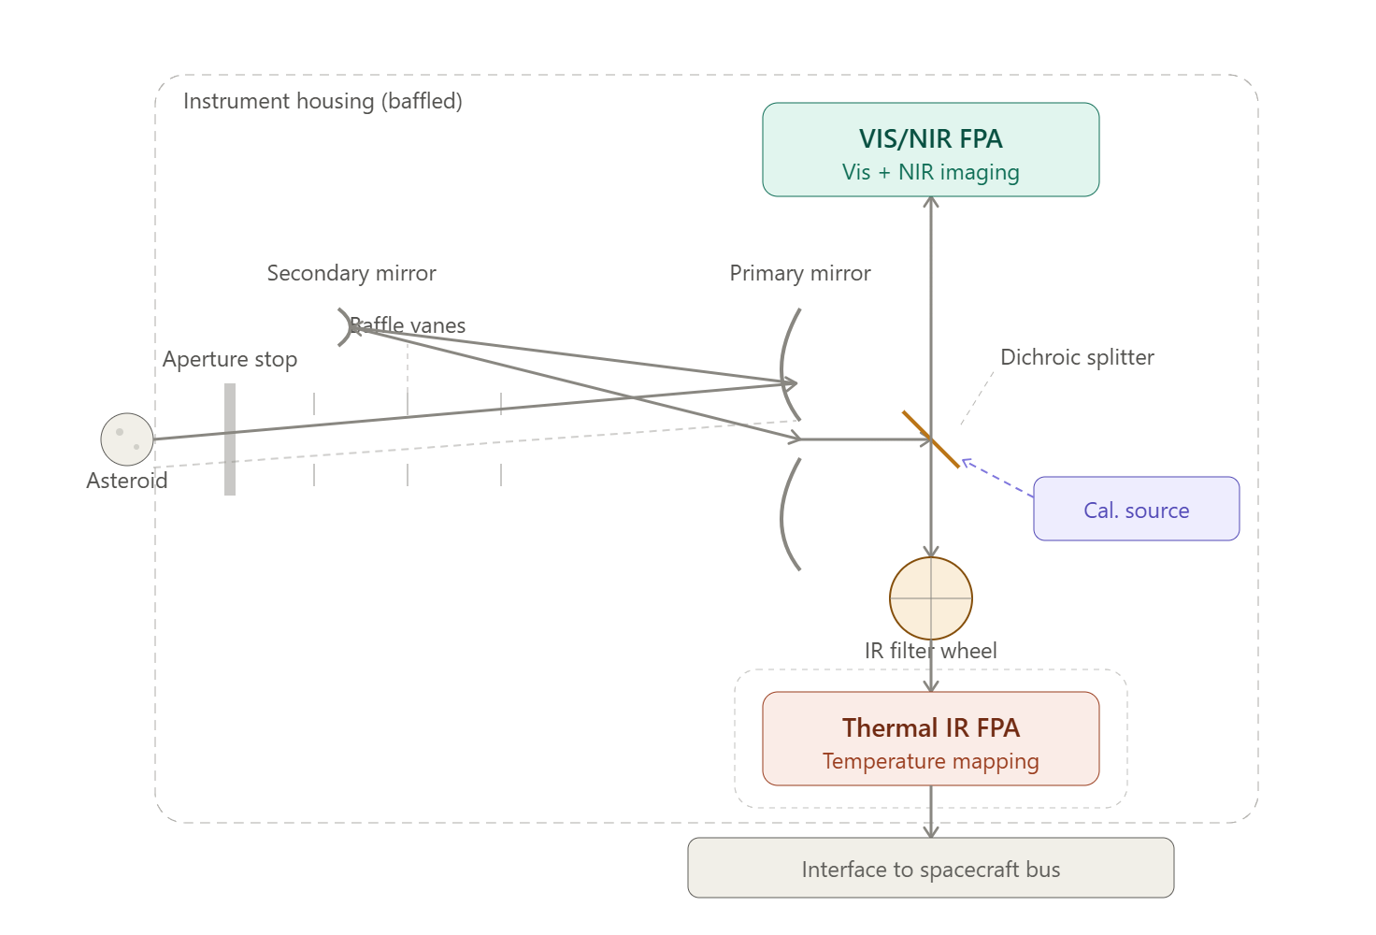
Figure 2– optical path from telescope to focal plane array

Detector suite
Visible/NIR imaging array paired with an uncooled or lightly cooled thermal infrared microbolometer array for surface temperature mapping. Lead: Nordholt Imaging Technologies (Waterloo, ON)

Instrument electronics & data processing
Onboard processor handling detector readout, data compression, autonomous target-prioritization logic, and instrument health monitoring. Lead: Chinook Avionics (Calgary, AB)

Thermal control
Passive radiator and heater system maintaining detector and electronics temperatures within operating limits through cruise and encounters. Lead: Laurentide Thermal Solutions (Montréal, QC)

Structure & mechanisms
Instrument housing, spacecraft mounting interface, and any scan or pointing mechanism supporting target tracking. Lead: Precambrian Structures Inc. (Sudbury, ON)

Calibration system
Onboard calibration source and reference targets supporting radiometric accuracy across all spectral bands. Lead: Meridian Calibration Labs (Halifax, NS)

Systems integration & test
Overall instrument integration, environmental qualification, and interface verification with the spacecraft bus. Lead: Northstar Space Systems (Toronto, ON)

Launch Segment description
The CASCE-hosting observatory will be launched aboard the Aurora-VI heavy-lift launch vehicle, injecting the spacecraft onto a direct transfer trajectory toward the Sun-Earth L2 Lagrange point. Following a transit period of approximately 30 days, the observatory will execute a series of trajectory correction maneuvers culminating in insertion into a halo orbit about L2, selected for its stable thermal environment, unobstructed sky visibility, and favorable conditions for sustained asteroid observation campaigns.
The launch vehicle is responsible for delivering the observatory to its target transfer trajectory within the accuracy required to minimize propellant expenditure for subsequent station-keeping and orbit-insertion maneuvers. Launch would occur from a European spaceport, consistent with the mission's European-led spacecraft and launch provision described in the mission concept. ESA is providing launch.

Ground Segment and Mission Operations
Mission operations for the observatory, including spacecraft commanding, orbit determination, station-keeping, and health and safety monitoring, will be conducted by ESA through its established ground segment and mission operations centre. In this arrangement, ESA also commands and controls the CASCE instrument itself, since CASCE is a passive optical instrument with no active pointing or scan mechanisms of its own — instrument operation is achieved through spacecraft pointing and standard command sequences integrated into ESA's overall mission timeline. This significantly reduces the scope of Canadian ground infrastructure required to support the mission, as no dedicated instrument command and control centre is needed.
Science and housekeeping data collected by CASCE will be downlinked via the ESA ground station network to ESA's mission operations centre, then delivered to an ESA-operated Science Data Centre responsible for archiving all observational data from the mission, including calibration products and metadata. This centre will serve as the authoritative long-term archive for the mission's science data, consistent with standard practice for ESA-led planetary science missions.
Canadian access to CASCE data will be provided through the Canadian Astronomy Data Centre (CADC), operated by the National Research Council of Canada, which will retrieve CASCE data products from the ESA Science Data Centre under a data-sharing agreement between the Canadian Space Agency and ESA. Canadian scientists will access, search, and download CASCE observations through the CADC's existing data access tools and user interfaces, consistent with how Canadian researchers access data from other international astronomy missions. This approach avoids duplicating ESA's data processing and archiving infrastructure while ensuring Canadian researchers have timely, familiar access to the mission's science products.
The interface between ESA's Science Data Centre and the CADC will be governed by a data-sharing agreement specifying data formats, delivery cadence, product versioning, and points of contact for resolving data-quality or delivery issues.

System Engineering and project management approach

TRL Levels and Heritage
CASCE will draw on heritage evidence where applicable, but the finalized baseline does not assume inheritance of the TRL of any reference spacecraft or instrument. Major spacecraft bus components are targeted to reach TRL ≥ 8 prior to flight qualification. Critical payload technologies are expected to be at TRL ≥ 6 at the start of Phase B2 development, advancing to TRL ≥ 8 prior to flight qualification. Commercial or heritage qualification evidence may only be reused where the configuration, environment, interfaces, and operating assumptions are demonstrated to be applicable to CASCE.

Phasing Logic and Naming conventions
For the finalized CADRe cost baseline, the PM nomenclature is B1, B2, C, D, E, and F. The nominal schedule is: B1 = 13 months (September 2026–October 2027); B2 = 9 months (October 2027–July 2028); C = 9 months (July 2028–April 2029); D = 25 months (April 2029–May 2031, including manufacturing, integration, test, launch and commissioning activities); E = 60 months (May 2031–May 2036); F = approximately 2 months for disposal/close-out. Thus, the nominal PM schedule contains 116 months from B1 start through the end of nominal operations, followed by a separate approximately 2-month Phase F close-out period. The detailed optimistic and pessimistic scenarios remain controlled in CADRe Part C and are not duplicated here.
The following are the phases in terms of costing:
Costing Nomenclature | Phase Description according to Costing Standards | Corresponding Name for Project team
PREP 1 | Prototyping Activities (before Gate 1) | N/A
PREP 2 | Prototyping Activities (during Phase 0/A) | N/A
Phase 0 | Concept & Feasibility Studies | Phase 0
Phase A | System Definition | Phase A
Phase B | Preliminary Design | Phase B
Phase C | Detailed Design | Phase C
MAIT | Manufacturing, Assembly, Integration and Test (of Canadian Systems, Subsystems and Components) | Phase D
SAIT | Spacecraft Assembly, Integration and Test | Phase D
LEOP | Launch and Early Operations (incl. commissioning) | Phase D
Phase E | Nominal Operations (per design life) | Phase E
Phase X | Extended operations (mission extension) | Extended ops
Phase F | Extended operations | Phase F
Phase G | Post-Mortem data utilization | N/A

CSA PRoject Milestones
The project has not created a schedule baseline yet. Assuming instrument level milestones will drive the CSA need dates.
Instrument Phases |  | Major Milestone | Milestone Date
Phase 0 | MCR | Mission Concept Review | Fall 2024
Phase A | SRR | System Requirements Review | Fall 2025
 |  | Mission Rebaseline | Spring 2026
Phase B | PDR | Preliminary Design Review | Winter 2027
Phase C | CDR | Critical Design Review | Spring 2028
MAIT | MRR | Manufacturing readiness Review | Winter 2029
MAIT | PSR | Pre-Ship Review of systems to Prime | Fall 2029
SAIT | SIR | System Integration Review | Spring 2030
SAIT | AR | Acceptance Review | Winter 2031
SAIT | PSR | Pre-Ship Review of S/C to Launch site | Spring 2031
LEOP | L | Launch | Fall 2031
LEOP | CR | Commissioning Review | Winter 2032
Phase E to F |  | Start of Nominal Ops | Winter 2032
Phase E to F |  | End of Nominal Ops | Spring 2037
Phase G |  | End of Life | Fall 2037

Safety and Mission Assurance
The CASCE program requires formal mission assurance, qualification, acceptance, verification, configuration control, and readiness reviews. Safety and mission-assurance effort is a direct cost and schedule driver, as the CASCE flight instrument must independently demonstrate conformity with the qualified design before delivery to the European spacecraft prime for integration and launch.

Qualification and Acceptance Strategy, MODEL Philosophy
The CASCE qualification and acceptance strategy will verify that the instrument is capable of surviving launch and performing its required functions throughout the planned mission lifetime. The approach uses one Qualification Model (QM) followed by a single Flight Model (FM), with engineering-model hardware used only where necessary to verify interfaces and reduce development risk.

The Qualification Model will represent the flight configuration as closely as practical and will undergo instrument-level environmental and functional testing, including vibration, thermal-vacuum, electromagnetic compatibility, and end-to-end functional testing. Optical performance, detector operation, electronics, data handling, and the interface to the host spacecraft will be verified. Existing qualification evidence may be used only where applicable to the CASCE configuration and operating environment.
Following successful qualification, the Flight Model will be manufactured to the qualified design and will undergo its own functional, electrical, calibration, and appropriate environmental acceptance testing before delivery to the European spacecraft prime for integration
The program also accounts for delivery logistics: the instrument will be transported under controlled configuration and environmental conditions, supported through integration with the host spacecraft, pre-launch functional checks, and secure transfer of configuration data.
Following launch, the instrument will undergo a commissioning period targeted to complete within 90 days, verifying power, pointing support, detector performance, calibration, initial observation quality, and ground-segment interfaces before transitioning to nominal operations.
All qualification and acceptance results will be documented through the CASCE verification and configuration-management process. Any anomalies identified during testing, delivery, integration, or commissioning will be assessed and resolved before CASCE is declared operational. Final approval for flight and entry into operational service will be based on completion of required verification activities and successful Flight Readiness and Operations Readiness Reviews.

Risk Assessment
The project team shall produce a risk register (ref CADRe part C)

Organizational Breakdown Structure
CSA Project Team: mission authority and program manager; responsible for systems engineering, payload integration, program management, technical authority, mission integration, mission planning, and government operations.Detector: Luquia (Quebec City, Canada) – formerly designed by INO
- ESA: principal international partner and host-spacecraft provider; provides the spacecraft bus, launch, and mission operations infrastructure, and coordinates instrument accommodation and pointing support for CASCE.
- CASCE payload: CSA; instrument electronics and data processing: CSA, with subsystem contributions from Canadian industry.
- Optics & telescope assembly: Borealis Optical Systems.
- Detector suite: Nordholt Imaging Technologies.
- Instrument electronics & data processing: Chinook Avionics.
- Systems integration & test: Northstar Space Systems, instrument prime contractor.
- Host spacecraft bus, ground segment, and launch: provided by ESA as part of the European-led mission.
- Science segment: Canadian university/research institutions.

Appendices

Acronym List

Acronym | Definition
CADRe | Cost Analysis Data Requirement
CSA | Canadian Space Agency
DND | Department of National Defence
EDA | Earth Daily Analytics
COS | Canadian Orbital Systems
NLS | Northern Launch Services
EO | Earth Observation
HEO | Highly Elliptical Orbit
VNIR | Visible and Near-Infrared
SWIR | Short-Wave Infrared
C&DH | Command and Data Handling
ADCS | Attitude Determination and Control System
TT&C | Telemetry, Tracking and Command
MPS | Mission Planning System
SCS | Spacecraft Control System
MCR | Mission Concept Review
PDR | Preliminary Design Review
CDR | Critical Design Review
MRR | Manufacturing Readiness Review
ETRR | Environmental Test Readiness Review
AR/SAR | Acceptance Review / System Acceptance Review
LRR | Launch Readiness Review
CCR | Commissioning Complete Review
LEOP | Launch and Early Orbit Phase
MAIT | Manufacturing, Assembly, Integration and Test
SAIT | Spacecraft/Segment Assembly, Integration and Test
TRL | Technology Readiness Level
QM | Qualification Model
FM | Flight Model
GSD | Ground Sample Distance
PCRA | Project Complexity and Risk Assessment

